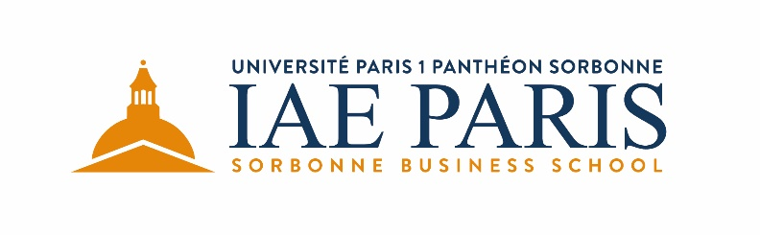

INTERNATIONAL MBA
Class of 2020-2022
APPLICATION FILE
- Application procedure and instructions
- Application form
- Letter of recommendation template

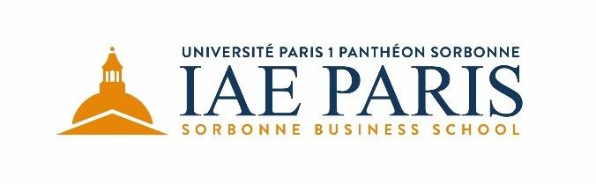

APPLICATION PROCEDURE
Admission deadline:
The admissions committee reviews applications as they are received. The application deadline for class of 2020 is June 30th, 2020 (program starts September 2020).
International MBA Program application form:
The application form asks for biographical and educational data. Short questions provide an opportunity for candidates to highlight their experience that is relevant to their application.
Letters of recommendation:
Two letters of recommendation are required from academic, professional and or social relationships who can provide a personal testimony of your strengths, weaknesses and qualifications for the International MBA Program. Please feel free to use the template enclosed at the end of this document.
Degrees and transcripts:
Candidates must submit one copy of their degrees including transcript of their grades.
Personal interview:
An interview will be scheduled with the International MBA Program Selection Committee. The interview allows an assessment of the candidate’s motivation ability to succeed in the program and language skills.
The interview also offers the candidate an opportunity to gain a greater perspective of the program and to discuss individual interests. The interview will take place in person or remotely (e.g. by video conference).
Personal interviews will be scheduled only once you have completed your application with all required documents.
Application fee:
The application fee for the International MBA Program is 100 €
(Application fee, approved by Decision of the Board of Directors of March 15th, 2016.)
Check should be made to order of: "Agent comptable IAE", and sent to :
IAE Paris
12 rue Jean Antoine de de Baïf
75013 Paris
Non-French citizens should pay with a foreign draft made payable to: "Agent comptable IAE".
Or by transfer:
IBAN: FR76 1007 1750 0000 0010 0517 284
BIC: TRPUFRP1

INSTRUCTIONS
Please fill in the application form and send with the following documents to:
imba.iae@univ-paris1.fr
Name files as follows : Your Last name_First name_nature of the document
- Copy of Passport
- Photo ID
- Copy of degrees earned and transcripts
- Score of a test of English language skills (for non-native speakers, not holding a degree fully taught in English): TOEIC, TOEFL, IELTS, PTE or BULATS.
- CV (resume)
- A letter of motivation including a description of your short-term and long term goals after completing the IMBA Program.
You may highlight the characteristics you possess that would make you a good fit for these goals.
- Two letters of recommendation from academic, professional and or social relationships
- A one-page essay in which you will discuss the most significant personal or professional risk you have taken and say what was the outcome
- Copy of application fee payment

INFORMATION
Program fee:
The program fee is 19 500 € and includes:
- Tuition and fees
- University registration fees for years 2020-2021 & 2021-2022
- Books and material
- Seminars (accommodation, train/plane tickets between Paris and destination, activities / companies visits)

Admission decision:
Once you have completed your application with all required documents and after the interview with the Selection Committee has been conducted, you will be notified within 10 days regarding admissions decision.

For more information:
Please contact Mr. Alexandre PALEOLOGOS
+ 33 (0) 1 44 08 73 67
imba.iae@univ-paris1.fr
You may also refer to our website at www.iae-paris.com

International MBA
Application Form

APPLICANT INFORMATION
☐Mr. ☐Ms.

Last name:
Maiden name:
First name:
Date of birth (dd/mm/yyyy):
Place of birth (City /Country):
Country of Citizenship:
Social Security Number (for French citizens):
Home address:
City:
Zip/Postal Code: Country:
Phone:
E-mail address:

Please select one of the following.
☐ I would prefer an in-person interview in Paris
☐ I would prefer a remote interview

EMPLOYMENT & PROFESSIONAL EXPERIENCE

- Total number of years of full-time work experience (post graduate employment) :
- Total number of years of managerial experience:

Beginning with your current position, please provide the following information regarding your professional experience.
If you have held more than one position with the same employer, please list them separately.

Current Position:
Employer:
Title/rank:
Nature/type of business:
Number of people under your supervision:
Time in current position:
Summary of responsibilities:

Previous Position:
Employer:
Title/rank:
Nature/type of business:
Number of people under your supervision:
Time in current position:
Summary of responsibilities:

List other activities, achievements, distinctions, honors or awards that you wish to mention:

EDUCATION

Highest Degree earned:
Major or concentration (if relevant):
Name of college or university City / Country:
Date of graduation (Month/Year):

- While attending college, were you employed?
☐Yes ☐No
if yes, ☐Full time ☐Part time

- Are your undergraduate grades an accurate indication of your potential in a graduate business program?

If not, please explain:

- List chronologically all other colleges and universities attended:
Name of college or university City / Country :
Dates :
From to
Degree awarded and date:

Name of college or university City / Country :
Dates : From to
Degree / Date awarded :
Use extra space if necessary:

ENGLISH & OTHER LANGUAGE SKILLS
- What is your mother tongue?
- Unless your mother tongue is English or if you hold a degree fully taught in English,
please provide a score of a test of English language skills
Test:
Score:
Date of test :
If you do not have a score yet, do you plan to take a test ?
Which test :
When:

- Please indicate any other languages you speak and your proficiency (basic, intermediate or advanced/fluent):

ADDITIONAL INFORMATION
Please list the names of the individuals that are providing a letter of recommendation for your application.

Name:
Title:
Company:
Address:
Phone number:
e-mail address:

Name:
Title:
Company:
Address:
Phone number:
e-mail address:

THIS FORM MUST BE SIGNED.
I certify that the information provided on this form and on any attached documents is true and accurate to the best of my knowledge. I understand that this form is only one part of the application process and that all application materials required by the International MBA Program and the IAE de Paris must be submitted for me to be considered for admission.

Please write full last name and first name as a signature:

Letter of recommendation template

The following applicant has requested you as a recommender to the INTERNATIONAL MBA Program at IAE Paris – Sorbonne Business School.
Letters of recommendation are considered an important part of the application process.
Please answer to the questions below as thoroughly as possible.
Feel free to create a separate document. You may return your letter to the student.
Your time and thoughtfulness are greatly appreciated.

Name of applicant
Name of recommender
Title
Institution
Address
Telephone

How long have you known the applicant?

Under what circumstances have you known the applicant?

What do you consider the applicant’s most outstanding talents or characteristics?

What are the applicant’s chief liabilities or weaknesses?

To what extent does the applicant demonstrate originality and independence in thinking?

Under what circumstances have you observed this?

How will the International MBA Program help the applicant to realize his or her goals?

Why would the candidate be an asset to an 18-month International MBA program?

Overall recommendation:
• Strongly recommend • Recommend • Recommend with reservations • Do not recommend

Date : Signature :

