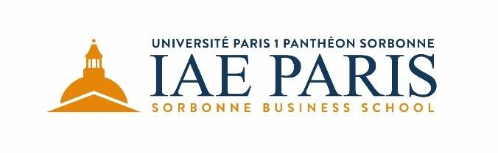

Application Procedure
Admission deadline
The admissions committee reviews applications as they are received. The application deadline for class of 2019 is June 30th, 2019 (program starts September 2019).
International MBA Program application form
The application form asks for biographical and educational data. Short questions provide an opportunity for candidates to highlight their experience that is relevant to their application.
Letters of recommendation:
Two letters of recommendation are required from social and professional relationships who can provide a personal testimony of your strengths, weaknesses and qualifications for the International MBA Program.
Degrees and transcripts:
Candidates must submit one copy of their degrees including transcript
Personal interview:
An interview will be scheduled with the International MBA Program Selection Committee. The interview allows an assessment of the candidate’s motivation ability to succeed in the program and language skills.
The interview also offers the candidate an opportunity to gain a greater perspective of the program and to discuss individual interests. The interview will take place in person or remotely (e.g. by video conference).
Personal interviews will be scheduled only once you have completed your application with all required documents.

Instructions
Please fill in the application form and send with to imba.iae@univ-paris1.fr .
- Copy of Passport
- Photo ID
- Copy of degrees earned and transcripts
- Score of a test of English language skills (for non-native speakers)
- CV (resume)
- Letter of motivation including a description of your short-term and long term goals after completing the IMBA Program. You may highlight the characteristics you possess that would make you a good fit for these goals.
- Two letters of recommendation social and professional relationships
- A one-page essay in which you will discuss the most significant personal or professional risk you have taken and say what was the outcome?

Information
Application fee
The application fee for the International MBA Program is 100 €
(Application fee, approved by Decision of the Board of Directors of March 15th, 2016.)
Check should be made to order of: "Agent comptable IAE", and sent to :
IAE Paris
12 rue Jean Antoine de de Baïf
75013 Paris
Non-French citizens should pay with a foreign draft made payable to: "Agent comptable IAE".
Or by transfer: IBAN: FR76 1007 1750 0000 0010 0517 284 / BIC: TRPUFRP1
Program fee
The program fee is 19 500 € and includes:
• Tuition and fees
• University registration fees for years 2019-2020 & 2020-2021
• Books and material
• Seminars (accommodation and train/plane tickets between Paris and destination)

Please send all material to:
imba.iae@univ-paris1.fr
Once you have completed your application with all required documents and after the interview with the Selection Committee has been conducted, you will be notified within 10 days regarding admissions decision.
Any questions regarding your application status should be directed to the Director of the International MBA Program.

For more information:
Please contact Mr. Alexandre PALEOLOGOS
+ 33 (0) 1 44 08 73 67
imba.iae@univ-paris1.fr
You may also refer to our website at www.iae-paris.com

